Photos of some of my Food technology and Hospitality students practical work while in lockdown.
Free choice practical Yr 11 Hos

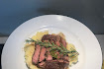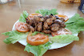
Coconut and citrus cup cakes Yr 11 Hos
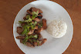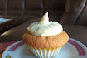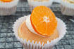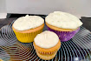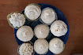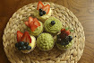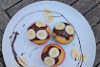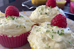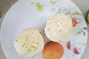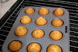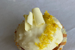
Sesame Marinated chicken Thigh Fillet with Rice YR 11 Hos

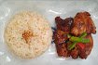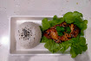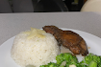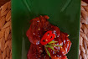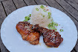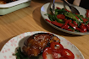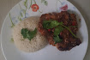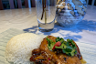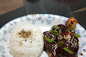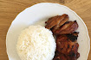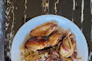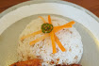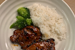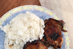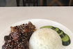

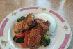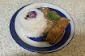

Tuna Melt Year 10
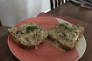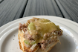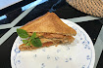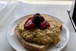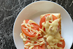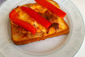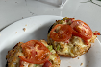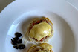

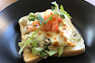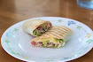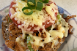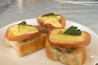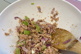

Year 9 Pearand Ginger puddigs

