

**QLD EOY Event**

**9am, Tuesday 24 Nov 15**

**Mercy Place Bardon**

[**qld@educateplus.edu.au**](mailto:qld@educateplus.edu.au)

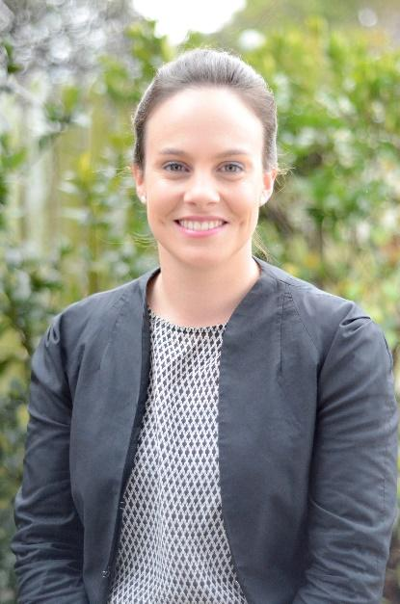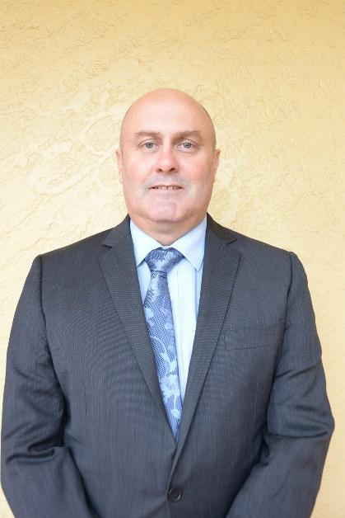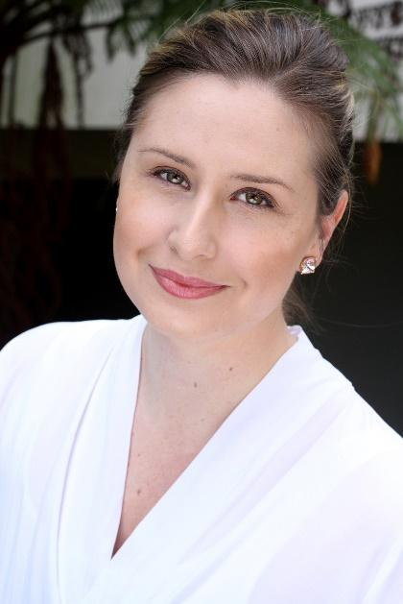

**Nicole Adele Kyle**

**Session 1 – A New School of Thought: Brisbane Boys College Award-Winning Team: Nicole deVries, Adele Graves and Kyle Thompson**

*In 2015, Brisbane Boys’ College (BBC) launched ‘A New School of Thought’ - a brand idea to clearly articulate the school’s identity and defining difference in the educational marketplace. The project – led by Nicole de Vries, Adele Graves and Kyle Thompson - set out to create not only a marketing campaign that would provide increased visibility and a unique positioning, but importantly to unite the entire school community to ensure BBC’s identity is not just a promise, but a promise delivered. An extensive consultation process of stakeholder groups informed the creation of the brand strategy, to ensure organisational alignment, a clear definition of purpose and a strong market proposition. The project also resulted in the creation of a new marketing campaign and a number of marketing materials in support of this.*

Come and hear from Nicole, Adele and Kyle as they share the collaboration and process behind the shift to ‘A New School of Thought’.

<http://www.bbc.qld.edu.au/>