CONFIDENTIAL
Adult Medicine Division Council

Advanced Training Curricula Renewal update
To: | Adult Medicine Division Council
Category: | For noting
Purpose: | To inform the Adult Medicine Division Council of updates in Advanced Training Curricula Renewal.
Synopsis: | This brief provides updates on Advanced Training Curricula Renewal, including:  - The common standards for Advanced Training curricula have been finalised.  - Development and consultation on competencies for Cultural Competence will continue.  - Next steps for Advanced Training curricula renewal in 2020.
Recommendation: | It is recommended that the Adult Medicine Division Council  - note the updates about Advanced Training Curricula Renewal.
Attachments: | Advanced Training curricula renewal at a glance
Prepared: | Katherine Deller, Senior Executive Officer, Advanced Training Curricula Renewal  Gemma Robinson, Education Development Officer, Advanced Training Curricula Renewal
Submitted: | Katherine Deller, Senior Executive Officer, Advanced Training Curricula Renewal

Advanced Training Curricula Renewal Update

Background
The purpose of the Advanced Training curricula renewal project is to:
- shift Advanced Training programs to a hybrid time- and competency-based training model
- align the Advanced Training programs with the RACP curricula frameworks and models
- update and rationalise existing curricula content and training requirements in Advanced Training programs.
Advanced Training curricula renewal is structured as a program of work encompassing several projects.
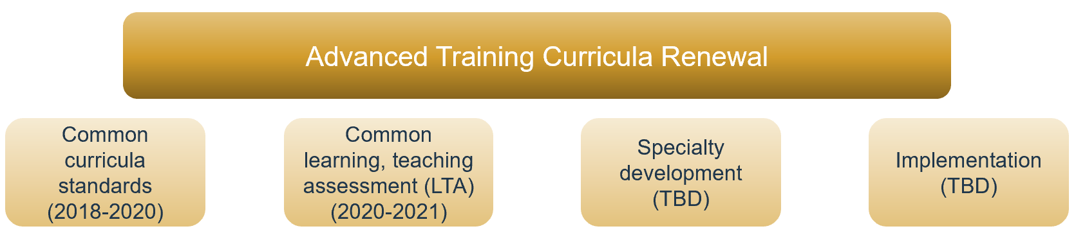
complete  cultural competence section in progress | in progress | planning underway | not yet started

Common standards
The College Education Committee approved and finalised the common standards for Advanced Training curricula in February 2020 and the standards have been published on the RACP website.
We would like to thank all RACP committees and members who participated in consultation activities on the draft common standards throughout 2019. Your robust and thoughtful feedback was used to identify and refine the content that is common across the Advanced Training programs.
We also received significant feedback on program-specific curriculum content. That feedback has been captured and will be used to support and inform program-specific curriculum development.
The common standards are not an entire curriculum, they are a component. In the new RACP curriculum model, a whole curriculum will comprise of a mixture of common curricula content and specialty-specific content, which will be supported by a learning, teaching and assessment program.

Applicability of the standards
The competencies will apply to all Divisional training programs. Applicability to some faculty training programs will vary and will need to be discussed individually with each of those specialty groups. Applicability to the Clinical Diploma in Palliative Medicine will also need to be determined.
The common EPAs can be divided into two groups: those that will apply across all training programs (EPA 1: Team leadership and EPA 2: Supervision and teaching) and those likely to apply to many/some programs. This notion is supported by the findings of the modified Delphi process and the consultation on the common standards.

Standards development
Draft common standards for Advanced Training were developed with the Curriculum Advisory Group in 2017-2018. In 2019 the proposed common standards underwent extensive consultation to:
- ensure the standards are at an appropriate level for the end of Advanced Training
- ensure the standards are assessable
- elicit feedback from a broad range of stakeholders to refine the standards.
Consultation feedback was reviewed by the Curriculum Advisory Group in December 2019 and the standards were amended accordingly. The final draft standards were submitted to the College Education Committee for approval, with a placeholder for Cultural Competence components which require further development work and consultation in collaboration with the Māori Health Committee and Aboriginal and Torres Strait Islander Health Committee.

Next steps
There is more work to be done to develop appropriate competencies for Cultural Competence so development and consultation will continue in that area throughout 2020.
This year the focus of Advanced Training curricula renewal will move to developing the common elements of the learning, teaching and assessment programs that will support the new Advanced Training curricula. Feedback on this will be sought later in the year.
Some specialties will also commence development of their program-specific content with assistance from the Curriculum Advisory Group and RACP Curriculum Team.
Further information about the program-specific review process will be shared later this year and members will continue to receive updates on Advanced Training curricula renewal throughout 2020.

